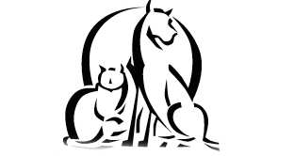
Del Rio Veterinary Diagnostic Hospital

Our healthcare plan is an affordable and convenient way to provide your pet with great medical care at a low monthly cost. You get to choose your pet’s health plan for the year starting with a comprehensive package. You may include any routine procedures such as spay, neuter, dental, laser declaw, and more. Pet medications, such as, heartworm prevention, routine prescriptions, and food.
We simply break your total down into twelve monthly payments. Included in the plan are six free office visits, for a savings of over $300.
Health Care Benefits
- Comprehensive Package
- 10% off Prescription Foods
- 10% off Dental Cleanings
- 6 Free Comprehensive Exam per year
- Enrollment Fee of $45.50
- Maintenance Fee of $42.00
- Per year

Comprehensive Exam Package
- Exam with Doctor
- Brief Ultrasound Cardiac & Abdominal
- Med-Rx (Video Ear Exam)
- Urinalysis
- Blood Profile Comprehensive
- Complete Blood Count
- Thyroid Blood Test (T4)
- Rabies Vaccine
- Distemper-Hepatitis-Parainfluenza-Parvovirus-Leptospirosis (DHPPL)
- Lymes Vaccine
- Bordetella Vaccine
- Heartworm Tick/Screen
- Fecal Examination

Ask us today about the Health Care Plan!
Office Hours
» Mon-Fri 7am-7pm
Sat 8am-4pm

» Mon-Fri appointments available:
8am-5:30pm

» Surgery Drop Off 7am-8am

» Sat appointments available:
8am-3pm

Emergency Hours
» Mon-Fri 6pm to
midnight
» Sat 3pm to midnight
» Sun 8am to midnight
» Emergency phone: 830-461-3766

Del Rio Veterinary
Diagnostic Hospital
(830)422-2129
(830)422-2251
DVDH@delriovet.net
www.delriovet.net
2450 Veterans Blvd
Del Rio, TX 78840
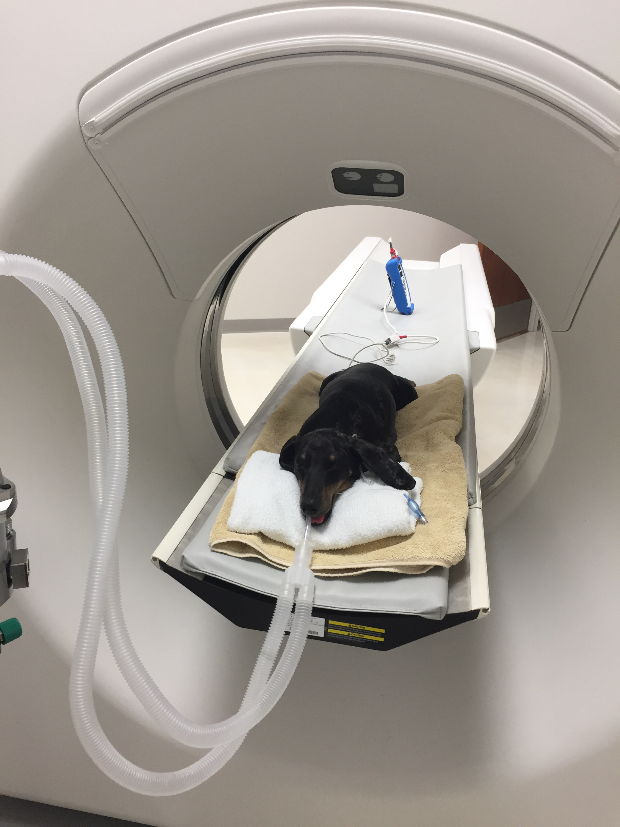  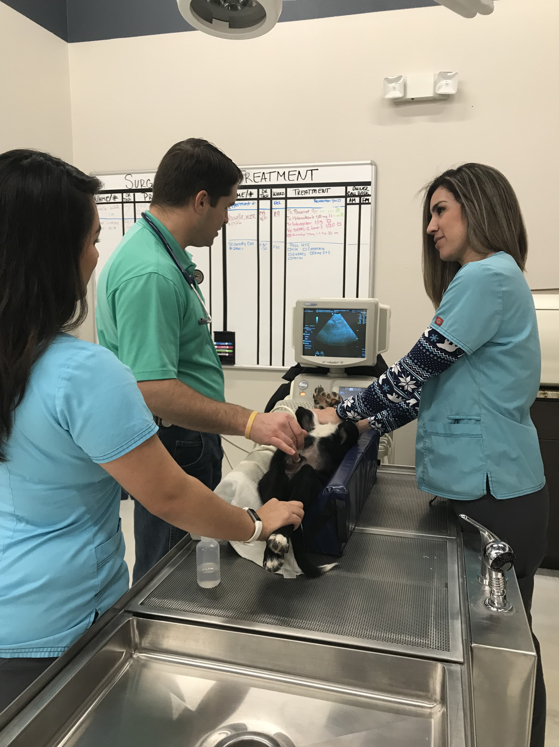 | EXAMPLE of Healthcare Plan:  - Enrollment Fee $45.50  - Maintenance Fee (Annual) $42.00  Due the day of Enrollment: $87.50  - Comprehensive Package $233.79  Standard Package Price with Free ultrasound  - Canine Dental Basic $212.18  Regular Price $235.76  - Exam Comprehensive x 6 $0.00  Savings of $316.68  - Interceptor Plus 8.1-25lbs for 12 months $88.92  - Nexgard 10.1-24lbs for 12 months  $299.76  Total: $821.15  Monthly Total: $68.43  You will be billed on the 1st of every month.  Kitties can have a plan too!  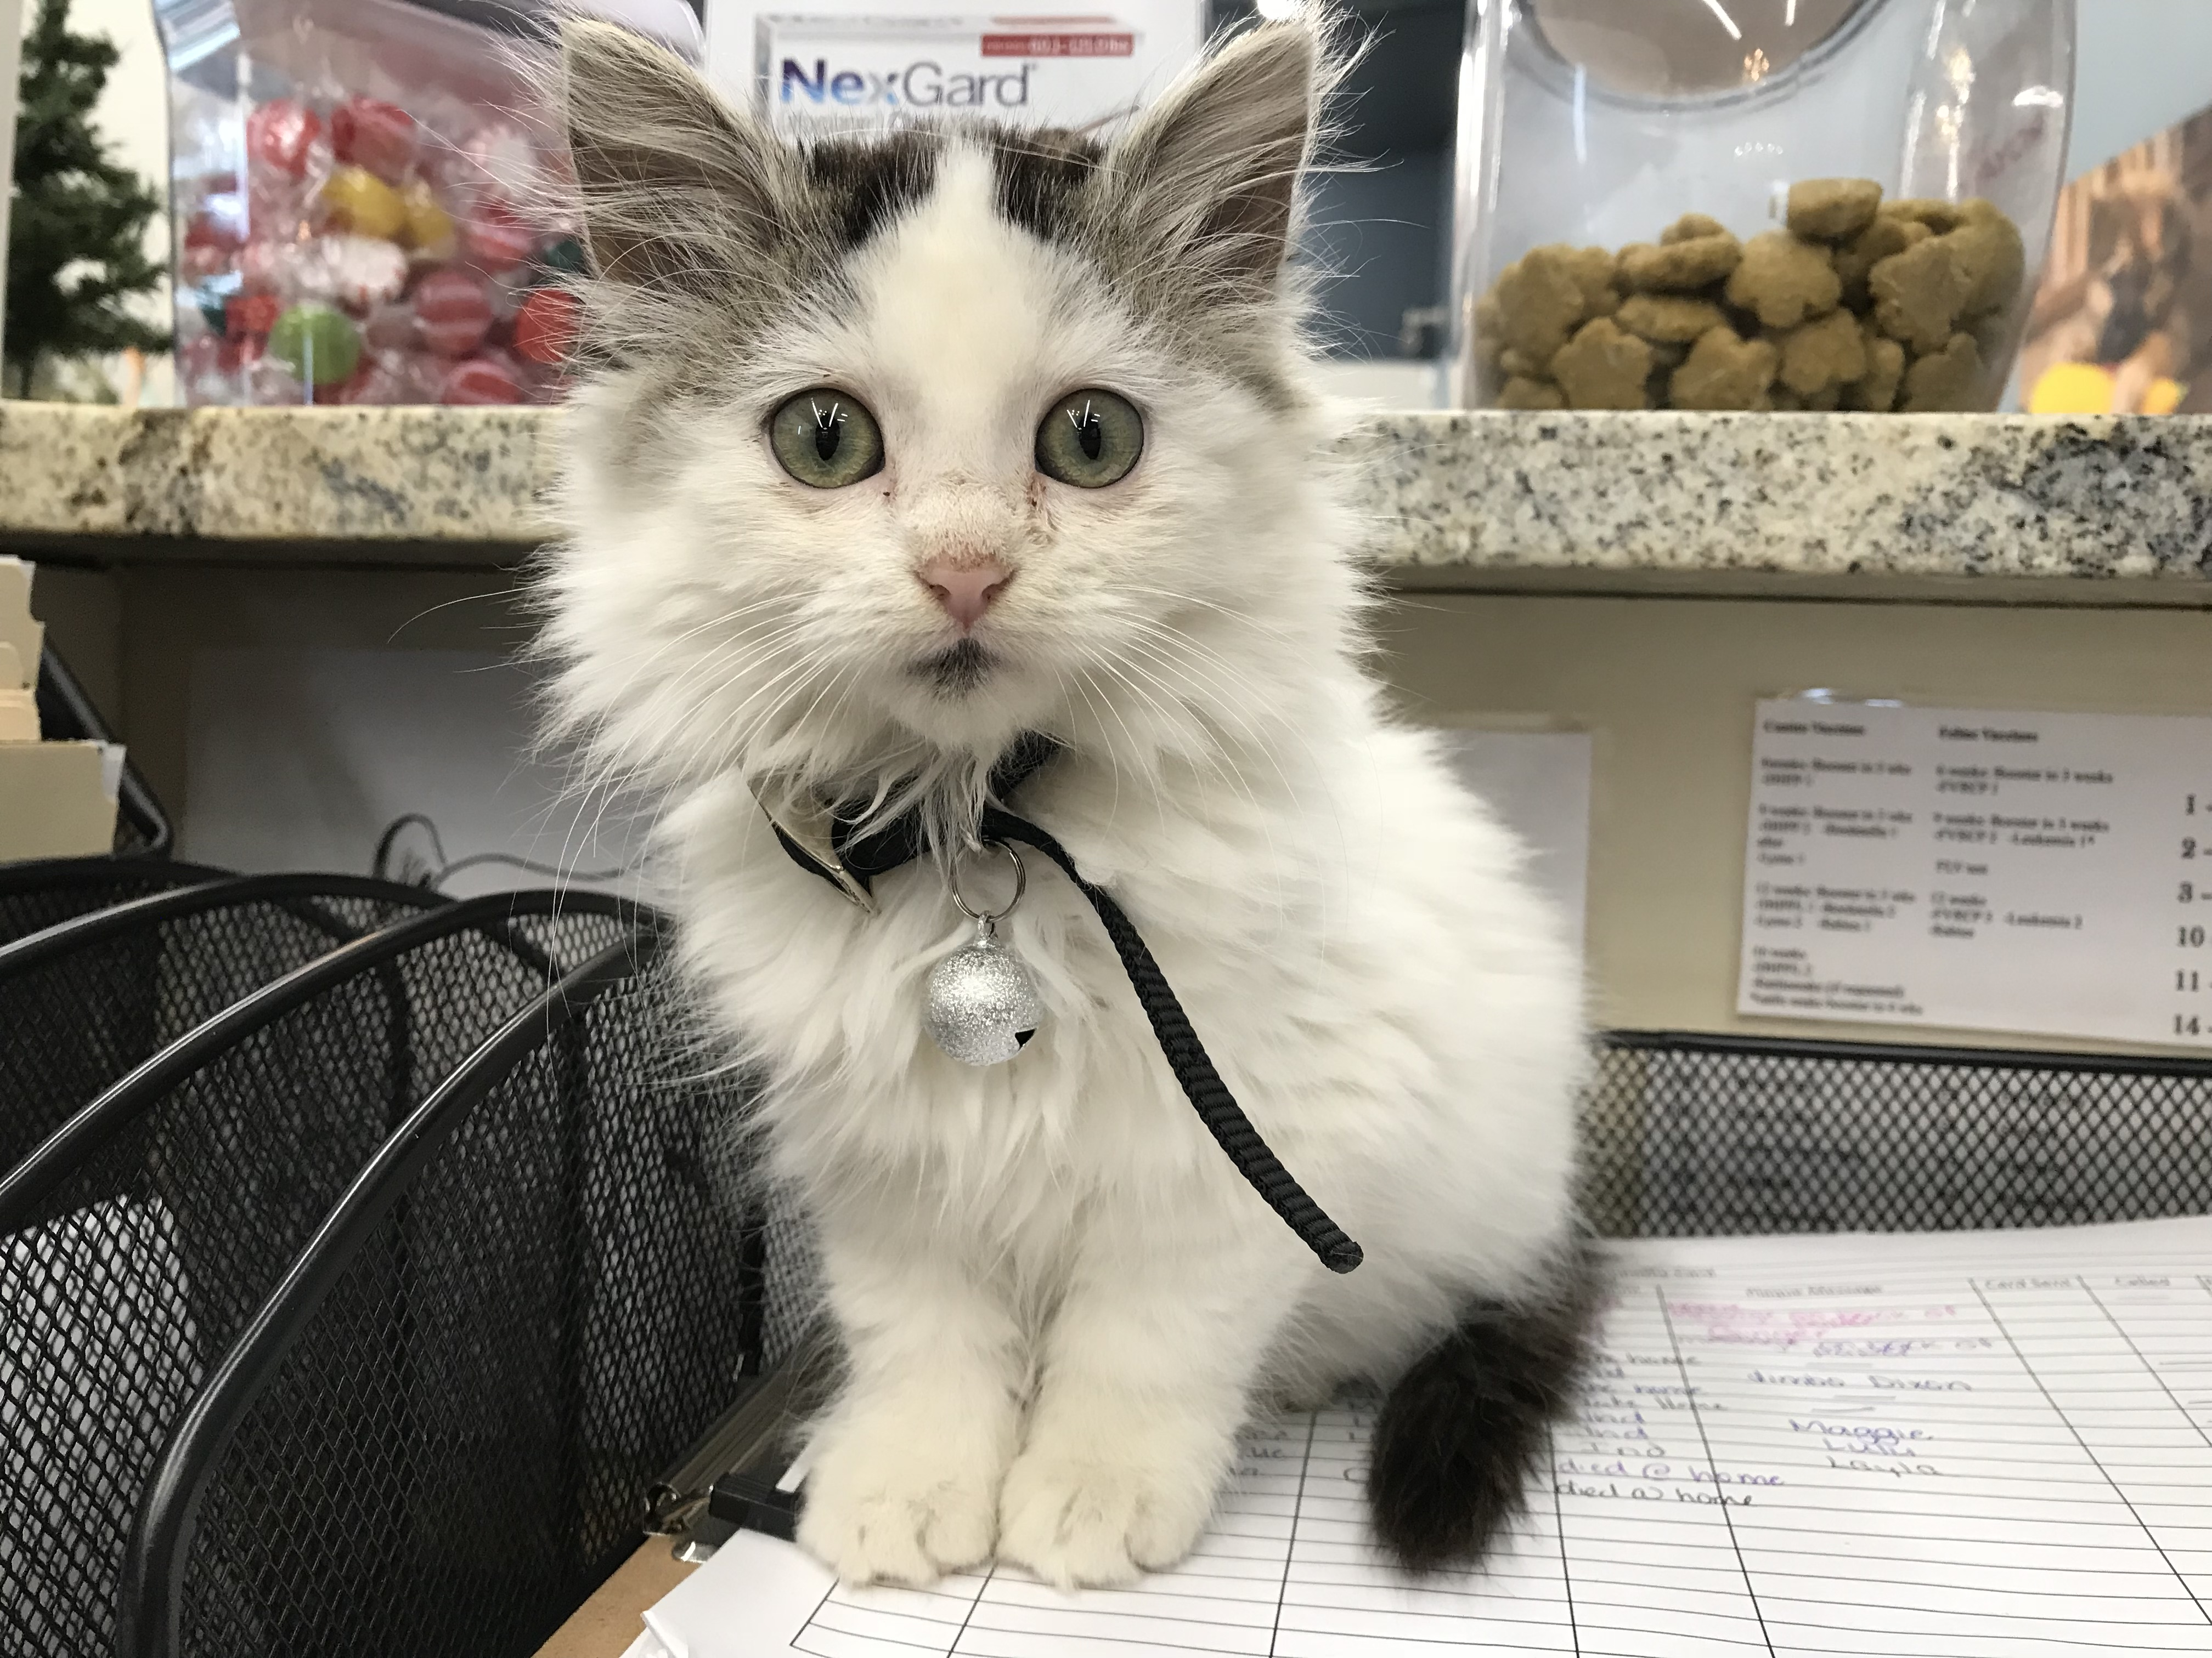 | Dentals:  Routine dental cleanings are important to your pet’s health. Excessive dental tartar allows bacteria from the mouth access to the blood stream and will affect the heart, kidneys, liver, and other internal organs. Keeping your pet’s teeth clean will add years to their life. Come see us today for a cleaning.  